|  |  |
| --- | --- |
| **Title:** | **WINLIFT**  **SW Component < 1.0 >** |

|  |  |  |  |  |
| --- | --- | --- | --- | --- |
| **History** | | | | |
| **Issue status**  (Index) | **Maturity/Date**  (draft/invalid/valid)  (dd-mmm-yyyy) | **Author**  Department | **Check/Release**  Department | **Description** |
| 1 | Draft  31-0ct-15 | Guillermo Ramirez  B.S. | Guillermo Ramirez  B.S. | Creation of the Software Design in repository |
| 2 | Draft  31-0ct-15 | Guillermo Ramirez  B.S. | Guillermo Ramirez  B.S. | Replacement of the SW Conceptual design diagram in section 4 and addition of component diagrams to 5 respectively. |
| 3 | Draft  31-0ct-15 | Oscar Miranda  B.S. | Oscar Miranda  B.S. | Modifications were made in chapter 5:Subtitles, Activity and sequence diagrams added. |
| 4 | Draft  31-0ct-15 | Oscar Miranda  B.S. | Oscar Miranda  B.S. | The activity diagram was modified because of some errors of the last version. |
| 5 | Draft  31-0ct-15 | Oscar Miranda  B.S. | Oscar Miranda  B.S. | Tha class diagram was added and also some functions in chapter 5 |
| 11 | Draft  2-Nov-15 | Oscar Miranda  B.S. | Oscar Miranda  B.S. | Only the return value of countPressTime was changed. |
| 12 | Draft  2-Nov-15 | Oscar Miranda  B.S. | Oscar Miranda  B.S. | References of requirements added. |
| 13 | Draft  2-Nov-15 | Guillermo Ramirez  B.S. | Guillermo Ramirez  B.S. | Functional Decomposition updated. Functions added and modification to some of the existing ones. Table of contents updated. |
| 15 | Draft  2-Nov-15 | Óscar Francisco  B.S. | Óscar Francisco  B.S. | Class diagram modified. Return values of the functions of sections 5.11 and 5.12 were changed, using naming convention. |
| 16 | Draft  2-Nov-15 | Óscar Francisco  B.S. | Óscar Francisco  B.S. | Description of the deployment, activity and class diagram modified and expanded. Class diagram was modified because of the name of the class was wrong and the elements of the e_wState were missed. |
| 21 | Draft  12-Nov-15 | Óscar Francisco  B.S. | Guillermo Ramirez  B.S. | History chart was re-formatted. Definitions of GPIO, STM, ISR and SIUL were placed in Abbrevation part of section 2. Section 3 modified and divided into two sub-sections because the constraints were added. |
| 35 | Draft  21-Nov-15 | Óscar Francisco  B.S. | Guillermo Ramirez  B.S. | API, MAL and HAL sections added in 5-2 Functional decomposition. Some API and HAL function charts modified, and other functions added. |
| 36 | Draft  22-Nov-15 | Óscar Francisco  B.S. | Guillermo Ramirez  B.S. | 5.3 SCHEDULER section added which contains the use of the scheduler, how to set a clock tick, and to add tasks. And the functional decomposition charts of files Secheduler, Os_Init, and Task_Init. |
| 37 | Draft  22-Nov-15 | Óscar Francisco  B.S. | Guillermo Ramirez  B.S. | Kernel() description added in section 5.3.1.1 and section 5.6 updated, because there were some errors in the sections number. |

**Table of Contents**

1 Purpose 5

2 Definitions and abbreviations 5

3 Realization constraints and targets 5

3.1 Targets 5

3.2 Constraints 6

4 SW Conceptual design 8

5 SW Component internal breakdown 9

5.1 Diagrams 9

5.1.1 Use Case Diagram 9

5.1.2 Deployment Diagram 10

5.1.3 Component Diagram 11

5.1.4 Activity Diagram 12

5.1.5 Class Diagram 13

5.1.6 Sequence Diagram 14

5.2 Functional Decomposition 14

*5.3* *SCHEDULER* 14

Use of the scheduler 14

Clock Tick 15

Tasks 15

*5.3.1* *Scheduler* 16

*5.3.1.1 void kernel(void)* 16

*5.3.2* *Os_init* 17

*5.3.2.1 void Tick_Flag(void)* 17

*5.3.3* *Task_init* 17

*5.3.3.1* *void VALIDATE(void)* 17

*5.3.3.2* *void CHECK_MANUAL_AUTO(void)* 18

*5.3.3.3* *void ANTI_PINCH(void)* 18

*5.3.3.4* *void STATE_MACHINE(void)* 18

*5.4* *API* 19

5.4.1 *WL_AppLayer* 19

*5.4.1.1* *T_ULONG WL_CheckValid(T_UBYTE channel)* 19

*5.4.1.2 T_ULONG WL_CheckAutoManual(void)* 19

*5.4.1.3* *void WL_WinMUp(void)* 20

*5.4.1.4* *void WL_WinMDw(void)* 20

*5.4.1.5* *void WL_WiAUp(void)* 21

*5.4.1.6* *void WL_WinADw(void)* 21

*5.4.1.7* *void WL_A_Pinch(void)* 22

*5.4.1.8* *void blockButtons(void)* 22

5.4.2 *State_Machine* 22

*5.4.2.1 void StateMachine(void)* 22

*5.5* *MAL* 23

*5.6* *HAL* 23

5.6.1 *Global_Init* 23

*5.6.1.1 void Global_Init(void)* 23

*5.6.1.2 void STM_init(void)* 23

*5.6.1.3 void initModesAndClock(void)* 23

*5.6.1.4 void GPIO_Init()* 24

*5.6.1.5 void GPIO_En(void)* 24

*5.6.1.6 void INTC__init(void)* 24

5.6.2 *GPIO_APP* 24

*5.6.2.1 T_UBYTE GPIO_GetState(T_UWORD ch)* 24

*5.6.2.2 void GPIO_SetState(T_UWORD ch, T_UBYTE value)* 25

# Purpose

The purpose of this project is develop a software, for an embedded system, that controls a car window movement, with anti-pitch security function. The software will be implemented in a MPC5606B Freescale development board.

# Definitions and abbreviations

**Definitions**

|  |  |
| --- | --- |
| WINLIFT | Name of the project, which means Window Lifter |
| API | May refer to Application Programming Interface or Application Layer |
| HAL | Hardware Abstraction Layer |
| MAL | Middleware Application Layer |
|  |  |

**Abbreviations**

|  |  |
| --- | --- |
| GPIO  ISR  STM  SIUL | General purpose inputs and outputs  Interrupt Service Routine  System Timer Module  System Integration Unit Lite |

**References**

|  |  |  |
| --- | --- | --- |
| **N°** | **Document name** | **Reference** |
| 1 | Traceability Matrix Template Rev. 35 | 1 |
| 2 | MPC5606B Reference Manual 7.1 | 2 |
|  |  |  |
|  |  |  |

# Realization constraints and targets

## Targets

The project has several functionalities to control the window, here is an overview of the principal ones:

* It will have a function that control the opening of the window. **Req. 2.1**
* It will have a function that control the closure of the window. **Req. 2.2**
* When opening or closing the window there will be an indicator LED indicating the process in progress. **Req. 2.8**
* There will be a function that counts how much time a button have been pressed and validate the press. **Req. 3 and Req. 3.1**
* It will have an anti-pinch functionality, declared as interruption, which will stop the closure of the window and will open it. This functionality is for security purposes. **Req. 4.3**
* When anti-pinch is active, a sub-function will disable all inputs for 5 seconds. **Req. 4.6**

## Constraints

A possible constraint could be the PowerPC architecture of the hardware where the software will be implemented, which is a development board MPC5606B of Freescale. Here are some concerning specifications and a block diagram that could help when trying to export the project into another platform:

* MPC5606B MCU in a 144LQFP package.
* On-board JTAG connection via open source OSBDM circuit using the MPC9S08JM MCU
* Operating Frequency (Max): 64 MHz.
* Total DMA Channels 16.
* Internal Flash (KB): 512
* GPIOs: 149.
* EEPROM: 64 KB DataFlash®
* RAM: Up to 96 KB
* Timer: 16 bits up to 64 channels

The principal modules (see block diagram) that are used in this project:

* SIUL:

-to configure GPIO and Pad Control (software control of external pins), used to declare the 10 output pins that will be connected to the LED’s that simulate the window and 3 inputs: closing/open/anti-pinch switches,

-and an ISR (used to make possible anti-pinch functionality)

* STM: used for timing purposes, that is, to configure the transitions of each led, the validation of a press button, and for deciding either to active an automatic opening/closure or a manual opening/closure. In total, the four channels of the STM are used.
* INTC: used to define the anti-pinch interrupt function.

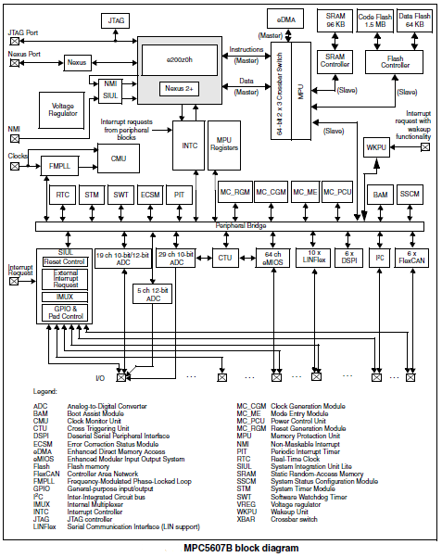

# SW Conceptual design

The next diagram represents the inputs and outputs of the WINLIFT’s conceptual design and the general tasks that must be performed.

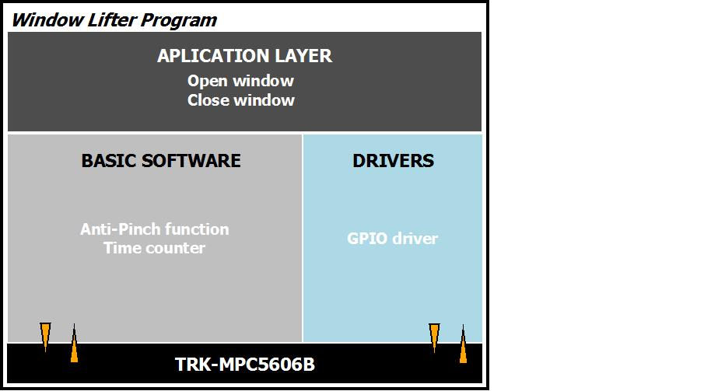

# SW Component internal breakdown

## Diagrams

### Use Case Diagram

The following Use Case diagram describes the general interaction between the main actor and the function that will be added to the program. It describes the over-all behavior of the window lift system.

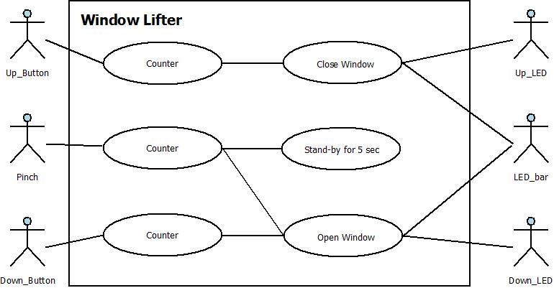

### Deployment Diagram

The following deployment diagram represents the inputs that are divided in three: Close, Open and anti-pinch; the outputs that are the LED simulation of the window, and the indicator LEDS, that display whether the window is lifting or lowering; the processing module that corresponds to the API, the HAL and the MCAL, in these modules the timings, the inputs and ouputs of the microcontroller and the interrupts are defined.

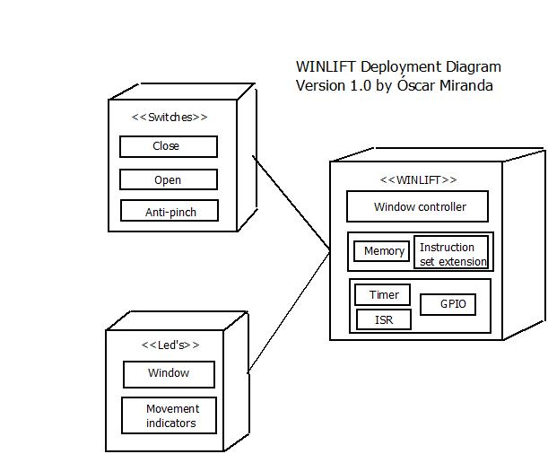

### Component Diagram

The following Component Diagram describes the structure and relations between the sub-systems comprehended in the Window Lifter system.

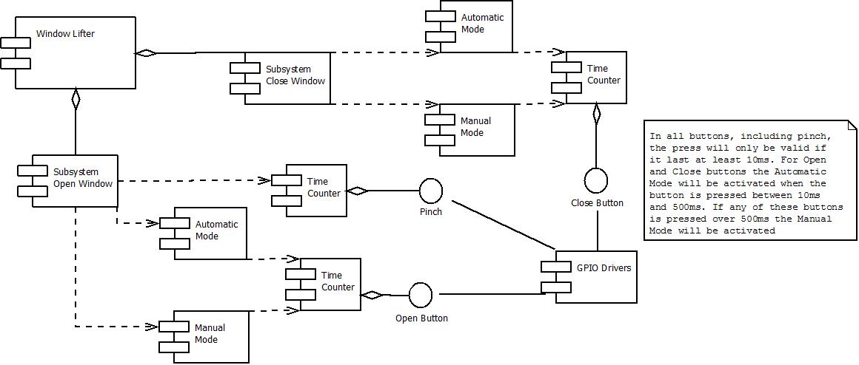

### Activity Diagram

The following flowchart defines all the default and other possible states of the window and requests of the processor, the operations like open or close window, the anti-pinch functionality, the validation of a button and the end of the program flow that is when the system is reset, or turned off.

Roughly, the process of the program begins with a default state, that is open, then the system have to wait for an input. If a button is pressed, first of all, the current state of the window must be checked to avoid errors, for example, only the anti pinch functionality have to be activated if the state of the window is Lifting. Depending on the button press time, the program will evaluate whether to select a manual closing, an automatic closing, or goes to wait. If the anti pinch button is pressed, all the inputs must be disable for 5 seconds and then goes wait. To exit of wait state, there are two options, either to turn off the system or enter an input.

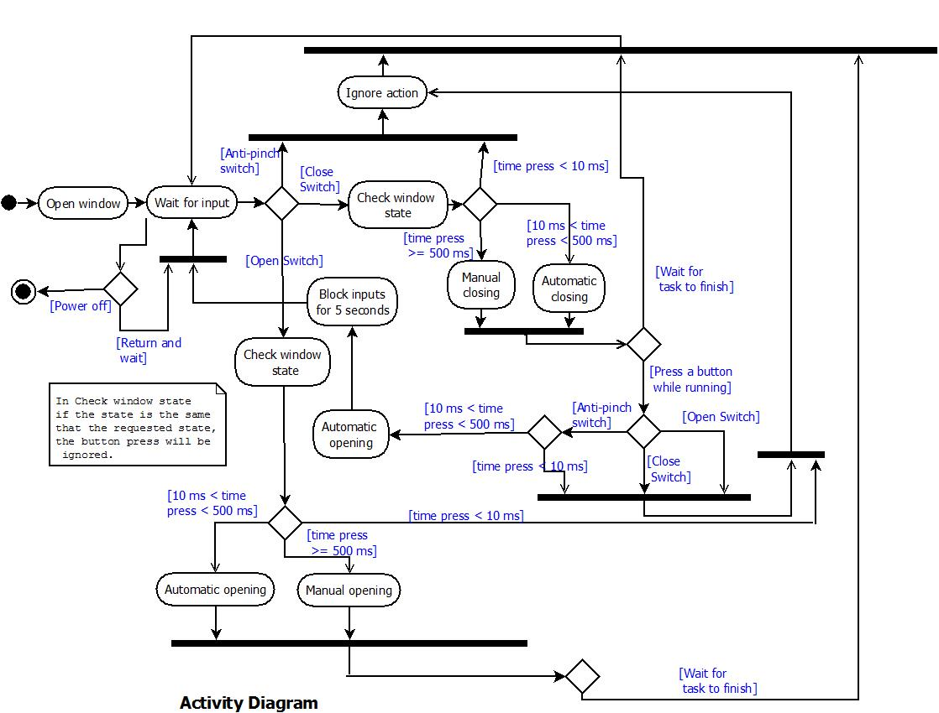

### Class Diagram

The class represents the API of WINLIFT. It has 10 methods and 1 attribute called e_wState that is an enum and refers to the state of the window and also has three values: CLOSE, OPEN and LIFTING. For more details of the functions go to section 5.2.

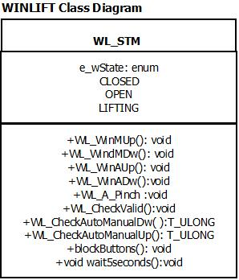

### Sequence Diagram

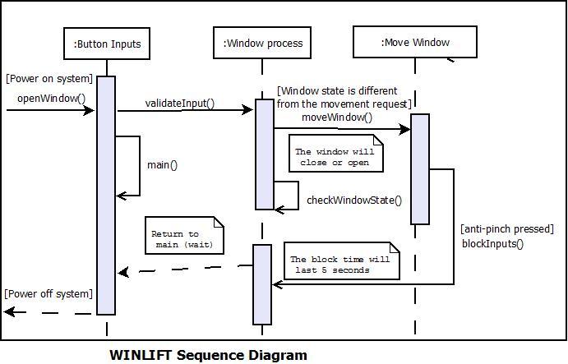This diagram represents a general flow of the WINLIFT software. Note that the function moveWindow() could be a openWindow() or a closeWindow() function, and while the system is running, the most of the time, it will wait for an input, until is turn off. The initial or default state is window open.

## Functional Decomposition

## ***SCHEDULER***

## Use of the scheduler

The scheduler controls the tasks with delays that are defined by the clock tick. To have a good performance of each task, a task must be small enough to fit within the clock tick. If a task is larger than the clock tick, it would be pause and will be dispatched in the next clock tick if other tasks are waiting. A task offset is necessary to avoid executing tasks at the same time, but this only reduces the possibility of such case, it doesn’t eliminate it.

## Clock Tick

The clock tick is set in the timer module (STM) of the hardware that runs at 16 MHz (this value can be modified) and an ISR function is used.

To establish the clock tick use the CMP register of the STM module using the following formula:

$$Clock Tick Hex= \frac{Clock Speed Hex}{1s}× Desired Clock Tick Time$$

Were *Clock Tick Hex* is a hexadecimal value, *Clock Speed Hex* is the hexadecimal magnitude of the clock speed, and *Desired Clock Tick Time* is the value in seconds of the Clock Time.

To keep the control of the clock tick a header, OS_Init.h, is used. It has a variable used to mark the deadline of the tick and the interrupt function **Tick_Flag()** that clears the **ub_TickFlag**, the clock interrupt flag of the STM, and reset the CNT register. This function is shown in the OS_Init.c file of the next page.

***OS_Init.h***

**T_UBYTE ub_TickFlag;**

**void** **Tick_Flag**(**void**);

***OS_Init.c***

**void** **Tick_Flag**(**void**)

{ /* -------------------------------------------------------------------

* Name : Tick_Flag

* Description : Check if the channel 0 of the STM as

reached 10ms and raise a flag when

reached

* Parameters : void

* Return : void

* ----------------------------------------------------------------

*/

**if** (STM.CH[0].CIR.B.CIF)

{

ub_TickFlag = 1; /* Clear tick clock flag */

STM.CH[0].CIR.B.CIF = 1; /* Clear interrupt flag */

STM.CNT.R = 0; /*Reset counter*/

}

}

## Tasks

To add a task:

In the TASK_Init.h add as much enums as necessary inside **E_TASK** enum, the most important constant is **E_TASK_NUM** that tells the number of the total tasks of the scheduler, this one must not be modified or moved as its used in other modules of the program.

Each task is defined by the following:

A structure S_TASK has three members:

* A handler called **rp_Tasks** to call the task,
* A 32 bit **rul_Period**, which is used to define the period of such task,
* A 32 bit **rul_Offset**, which is used to define the task’s offset.

The tasks are declared and defined in both, the TASK_Init.h and Task_Init.c files:

***TASK_Init.h***

**typedef** **struct** {

**void**(* rp_Tasks)(**void**); /*Pointer that'll call every task*/

T_ULONG rul_Period; /*Period of task*/

T_ULONG rul_Offset; /*Offset of task*/

}S_TASK;

**typedef** **enum**{

*E_TASK1*,

*E_TASK2*,

…/* NEW TASK MUST BE ADDED HERE */ …

*E_TASK_NUM*

}E_TASK;

In the TASK_Init.c, an array of **S_TASK** variables must be used to define the tasks pointer, and to define the periods and offsets the format will be the following:

***TASK_Init.c***

**#define** taskPeriod1 XXXX

… …

**#define** taskPeriodN XXXX

**#define** taskOffset1 XXXX

… …

**#define** taskOffsetN XXXX

**const** S_TASK taskName[*E_TASK_NUM*] = {

{taskName1, taskPeriod1, taskOffset1 },

{taskName2, taskPeriod2, taskOffset2 },

{taskName3, taskPeriod3, taskOffset3 },

… … … …

{taskNameN, taskPeriodN, taskOffsetN }

};

Note that **E_TASK_NUM** represents the number of tasks, in this case, four tasks, and that the period and the offset are numeric values.

### Scheduler

### 5.3.1.1 void kernel(void)

|  |  |
| --- | --- |
| **Description** | The scheduler is contained inside a function called kernel. This function starts by doing an indexing of the task, assigning the offset. This process occurs only once in each execution of the code.  Then an infinite loop starts, the tick of the scheduler is defined by a flag called ub_TickFlag, which was configured to raise every millisecond. Once it was acquired it is restarted to zero.  Now, inside the if there is a for cycle which who through all the task accessing to their offset with and if, whenever the offset is over zero it will decrease, for every task. When one of the offset, of whichever task, reach zero, the else of the if will be active and will stablish the period of the task and will call it using the pointer previously defined. |
| **Parameters** | void |
| **Return Value** | *void* |
| **Precondition** | ------------ |
| **Post condition** | ------------------ |
| **Error Conditions** | *Not defined* |
| **Requirement** | -------- |

### Os_init

### 5.3.2.1 void Tick_Flag(void)

|  |  |
| --- | --- |
| **Description** | Check if the channel 0 of the STM as reached 1ms  and set a flag called ub_TickFlag when reached. |
| **Parameters** | void |
| **Return Value** | *void* |
| **Precondition** | The counter value of the STM is equal to the compare value of channel 0 and counter interrupt flag has been set. |
| **Post condition** | ------------------ |
| **Error Conditions** | *Not defined* |
| **Requirement** | -------- |

### Task_init

### 5.3.3.1 void VALIDATE(void)

|  |  |
| --- | --- |
| **Description** | Read the state of the UP and DOWN switches, if  one of them is on it will call the WL_CheckValid  function to verify if its valid. This will happen  as long as the state_flag is E_DEFAULT, this to  prevent that the function is called once it had been  validated and the window is in movement. |
| **Parameters** | No parameters |
| **Return Value** | *No return value* |
| **Precondition** | Either is the first task the scheduler calls or task STATE_MACHINE() has been called by the scheduler. And UP or DOWN are on. |
| **Post condition** | Task ANTI_PINCH is the next task that the scheduler will select |
| **Error Conditions** | *Not defined* |
| **Requirement** | 3.1 |

### 5.3.3.2 void CHECK_MANUAL_AUTO(void)

|  |  |
| --- | --- |
| **Description** | Once the button had been validated, read the state  to verify that is still on, if one of them is on  it will call the WL_CheckAutoManual To change the  state_flag to the corresponding MANUAL or AUTO routine.  This will happen as long as the state_flag is different  from E_ANTIPINCH, this to prevent that the function is  called during the anti-pinch routine. |
| **Parameters** | No parameters |
| **Return Value** | *No return value* |
| **Precondition** | Task VALIDATE() has been called by the scheduler. And a button is on. |
| **Post condition** | Task ANTI_PINCH is the next task that the scheduler will select |
| **Error Conditions** | *Not defined* |
| **Requirement** | 3.3 |

### 5.3.3.3 void ANTI_PINCH(void)

|  |  |
| --- | --- |
| **Description** | This function can only be called if the window is  moving up (closing), or if the anti-pinch has already  been activated. It will read the state of the SW_A_PINCH  if its on, it check if its a valid press. Once it has been  validated it will change the state_flag to E_ANTIPINCH |
| **Parameters** | No parameters |
| **Return Value** | *No return value* |
| **Precondition** | Task CHECK_MANUAL_AUTO() has been called by the scheduler. And the window is lifting. |
| **Post condition** | Task STATE_MACHINE() is the next task the scheduler will select |
| **Error Conditions** | *Not defined* |
| **Requirement** | 3.3, 4.3, 4.4, 4.5 and 4.6 |

### 5.3.3.4 void STATE_MACHINE(void)

|  |  |
| --- | --- |
| **Description** | This function calls the state machine that controls  the window movement, depending on the flags defined  by the previous functions. It will always be called. See function 5.4.2.1 StateMachine() |
| **Parameters** | No parameters |
| **Return Value** | *No return value* |
| **Precondition** | Task ANTI_PINCH() has been called by the scheduler. |
| **Post condition** | Task VALIDATE() is the next task the scheduler will select |
| **Error Conditions** | *Not defined* |
| **Requirement** | ------- |

## ***API***

### ***WL_AppLayer***

### 5.4.1.1 T_ULONG WL_CheckValid(T_UBYTE channel)

|  |  |
| --- | --- |
| **Description** | As long as a button is press, check if the button  press is valid (to avoid debounce), the button  verifies is the one specified in channel. If it  have not reached yet increase the lul_ValidTime  by one, every time that the function is called,  and returns a invalid value in the lub_Valid  variable. When the counter reach 10, lub_Valid  return a valid value |
| **Parameters** | T_UBYTE channel  The GPIO register number of the push buttons, up(close), down(open) and anti-pinch |
| **Return Value** | *T_ULONG lub_Valid*  *This variable determines whether a press button is valid (greater than 10 ms) or invalid (lower than 10 ms)* |
| **Precondition** | up(close), down(open) or anti-pinch button must have been pressed |
| **Post condition** | ------------------ |
| **Error Conditions** | *Not defined* |
| **Requirement** | Req 3.1 |

### ***5.4.1.2 T_ULONG WL_CheckAutoManual(void)***

|  |  |
| --- | --- |
| **Description** | As long as a button is press, and it has been  validated, check if the routine to execute is  manual or automatic, this will be for the  movement specified in channel (Up or Down).  If the counter (lul_PressTime) do not reached 490  counts (which will be 500 when the 10 in WL_CheckValid()  are counted) is AUTO. But if the counter (lul_PressTime)  reached 490 counts it will be manual. |
| **Parameters** | T_UBYTE channel  The GPIO register number of the push buttons, up(close), down(open) and anti-pinch |
| **Return Value** | *T_ULONG lub_ValidMA*  *Determines either to execute a manual action or an automatic action* |
| **Precondition** | Up (Close) or Down (Open) button pressed and the button press was validated by WL_CheckValid() |
| **Post condition** | *Prepares the window to move manually or automatically using the variable lub_ValidMA* |
| **Error Conditions** | *Not defined* |
| **Requirement** | Req 3.3 |

### ***5.4.1.3 void WL_WinMUp(void)***

|  |  |
| --- | --- |
| **Description** | Close the window manually by making a "sweep"  through the LED_BAR, as long as rsw_WindowPos  is bigger than NUMLEDS, which means that the window  is not completely close yet. As long as the SW_UP  button is pressed the sweep will turn on a LED  every 400 counts of lul_TimeCounterUp. Once it reaches  400 the counter is reset and rsw_WindowPos increase by  one, to turn on a different LED the next time.  While the button is pressed, state_flag, will be E_MANUAL_UP,  but when is completely close, or the button is not pressed any  more, state_flag will be E_DEFAULT. |
| **Parameters** | No parameters |
| **Return Value** | *There is no return value* |
| **Precondition** | Only can be called when the when up button is pressed during 500 ms |
| **Post condition** | *Leds’ transition down-to-up executes* |
| **Error Conditions** | *Not defined* |
| **Requirement** | Req 2.6, 3.3 |

### ***5.4.1.4 void WL_WinMDw(void)***

|  |  |
| --- | --- |
| **Description** | Open the window manually by making a "sweep"  through the LED_BAR, as long as rsw_WindowPos  is minor than NUMLEDS, which means that the window  is not completely open yet. As long as the SW_DOWN  button is pressed the sweep will turn off a LED  every 400 counts of lul_TimeCounterDw. Once it reaches  400 the counter is reset and rsw_WindowPos decrease by  one, to turn off a different LED the next time.  While the button is pressed, state_flag, will be E_MANUAL_DW,  but when is completely open, or the button is not pressed any  more, state_flag will be E_DEFAULT. |
| **Parameters** | No parameters |
| **Return Value** | *There is no return value* |
| **Precondition** | Only can be called when the down(open) button is pressed more than 500 ms |
| **Post condition** | *Leds’ transition up-to-down executes* |
| **Error Conditions** | *Not defined* |
| **Requirement** | Req 2.6, 3.3 |

### ***5.4.1.5 void WL_WiAUp(void)***

|  |  |
| --- | --- |
| **Description** | Close the window automatically by making a "sweep"  through the LED_BAR, as long as rsw_WindowPos  is bigger than NUMLEDS, which means that the window  is not completely close yet. It will turn on a LED  every 400 counts of lul_TimeCounterUp. Once it reaches  400 the counter is reset and rsw_WindowPos increase by  one, to turn on a different LED the next time.  While the window is not close yet, state_flag, will be E_MANUAL_UP,  but when is completely close, state_flag will be E_DEFAULT. |
| **Return Value** | *There is no return value* |
| **Precondition** | Only can be called when the when up(close) button is pressed between 10ms (valid press) and 400 ms |
| **Post condition** | *Leds’ transition down-to-up executes* |
| **Error Conditions** | *Not defined* |
| **Requirement** | Req 2.6, 3.3 |

### ***5.4.1.6 void WL_WinADw(void)***

|  |  |
| --- | --- |
| **Description** | Open the window automatically by making a "sweep"  through the LED_BAR, as long as rsw_WindowPos  is minor than NUMLEDS, which means that the window  is not completely open yet. It will turn on a LED  every 400 counts of lul_TimeCounterDw. Once it reaches  400 the counter is reset and rsw_WindowPos decrease by  one, to turn off a different LED the next time.  While the window is not open yet, state_flag, will be E_MANUAL_DW,  but when is completely open, state_flag will be E_DEFAULT. |
| **Parameters** | No parameters |
| **Return Value** | *There is no return value* |
| **Precondition** | Only can be called when the down button is pressed between 10 ms (valid press) and 400 ms |
| **Post condition** | *Leds’ transition up-to-down executes* |
| **Error Conditions** | *Not defined* |
| **Requirement** | Req 2.6, 3.3 |

### ***5.4.1.7 void WL_A_Pinch(void)***

|  |  |
| --- | --- |
| **Description** | This function can only be called when the window is  going up, it ensures that the LED_UP is turned off.  Then open the window automatically using WL_WinADw, when  the window is completely open calls the blockButtons  function. |
| **Parameters** | No parameters |
| **Return Value** | *There is no return value* |
| **Precondition** | Up (close) button pressed and WL_WinAUp() or WL_WinMUp() were executed |
| **Post condition** | *Block all inputs during 5 seconds using blockButtons()* |
| **Error Conditions** | *Not defined* |
| **Requirement** | Req 3.1, 4.3, 4.4, 4.5 4.6 |

### ***5.4.1.8 void blockButtons(void)***

|  |  |
| --- | --- |
| **Description** | Disable the inputs buttons and creates and wait 5s  before re-enable them. Every time the function is called  lul_Counter will increase by one, if it has not reached  5s (or 5000 counts) state_flag will be E_ANTIPINCH. When  it reached the 5s the buttons re-enable and state_flag changes  to E_DEFAULT. |
| **Parameters** | No parameters |
| **Return Value** | *There is no return value* |
| **Precondition** | rsw_WindowPos is equal to zero when WL_A_Pinch() was executed |
| **Post condition** | *Enable all the inputs* |
| **Error Conditions** | *Not defined* |
| **Requirement** | Req 4.6 |

### ***State_Machine***

### ***5.4.2.1 void StateMachine(void)***

|  |  |
| --- | --- |
| **Description** | It calls a different state, or window movement case,  depending on the value of state_flag, which is  established by the tasks in the Scheduler. There are 6 states: E_MANUAL_UP, E_AUTO_UP, E_MANUAL_DW, E_AUTO_DW, E_ANTIPINCH and E_DEFAULT |
| **Parameters** | No parameters |
| **Return Value** | *There is no return value* |
| **Precondition** | ---- |
| **Post condition** | *----* |
| **Error Conditions** | *Not defined* |
| **Requirement** | 3.3, 4.3,4.4,4.5,4.6 |

E_MANUAL_UP refers to a manual closing of the window.

E_AUTO_UP refers to an automatic closing of the window

E_MANUAL_DW refers to a manual opening of the window

E_AUTO_DW refers to automatic opening of the window

E_ANTIPINCH refers to the anti_pinch functionality of the window

E_DEFAULT refers to the default state of the window, where no indicator leds are on.

## ***MAL***

## ***HAL***

### ***Global_Init***

### ***5.6.1.1 void Global_Init(void)***

|  |  |
| --- | --- |
| **Description** | Initializes the modes and clock of the system, the STM module, the GPIO ports, and the software interrupts of INTC |
| **Parameters** | No parameters |
| **Return Value** | *There is no return value* |
| **Precondition** | Main(has started) |
| **Post condition** | *----* |
| **Error Conditions** | *Not defined* |
| **Requirement** | ----- |

### ***5.6.1.2 void STM_init(void)***

|  |  |
| --- | --- |
| **Description** | Enables the STM module and configures the prescaler, the channel 0, and the compare registers |
| **Parameters** | No parameters |
| **Return Value** | *There is no return value* |
| **Precondition** | Global_Init(called) |
| **Post condition** | *----* |
| **Error Conditions** | *Not defined* |
| **Requirement** | ------ |

### ***5.6.1.3 void initModesAndClock(void)***

|  |  |
| --- | --- |
| **Description** | Enables the run mode and the signal clock speed to 64 MHz |
| **Parameters** | No parameters |
| **Return Value** | *There is no return value* |
| **Precondition** | Global_Init(called) |
| **Post condition** | *----* |
| **Error Conditions** | *Not defined* |
| **Requirement** | ------ |

### ***5.6.1.4 void GPIO_Init()***

|  |  |
| --- | --- |
| **Description** | Enables the pins –using GPIO_En() function- that will be used for the led bar, the led up and down indicators as outputs and the up(close), down(open), and anti-pinch buttons as inputs. |
| **Parameters** | No parameters |
| **Return Value** | *There is no return value* |
| **Precondition** | Global_Init(called) |
| **Post condition** | *----* |
| **Error Conditions** | *Not defined* |
| **Requirement** | 1.2, 2.1, 2.7 and 4.2 |

### ***5.6.1.5 void GPIO_En(void)***

|  |  |
| --- | --- |
| **Description** | Enables a pin of the GPIO that will be used |
| **Parameters** | No parameters |
| **Return Value** | *There is no return value* |
| **Precondition** | Global_Init(called) |
| **Post condition** | *----* |
| **Error Conditions** | *Not defined* |
| **Requirement** | ------ |

### ***5.6.1.6 void INTC__init(void)***

|  |  |
| --- | --- |
| **Description** | Enables software interrupts |
| **Parameters** | No parameters |
| **Return Value** | *There is no return value* |
| **Precondition** | Global_Init(called) |
| **Post condition** | *----* |
| **Error Conditions** | *Not defined* |
| **Requirement** | ------ |

### ***GPIO_APP***

### ***5.6.2.1 T_UBYTE GPIO_GetState(T_UWORD ch)***

|  |  |
| --- | --- |
| **Description** | Get the state of a pin, the pin is defined in ch, that is, it reads if the pin is on or off. |
| **Parameters** | T_UWORD ch  Number of the GPIO register/channel |
| **Return Value** | *T_UBYTE result*  *Pin reading (on/off) of specified channel* |
| **Precondition** | Global_Init(called) |
| **Post condition** | *----* |
| **Error Conditions** | *Not defined* |
| **Requirement** | 1.2, 4.2 |

### ***5.6.2.2 void GPIO_SetState(T_UWORD ch, T_UBYTE value)***

|  |  |
| --- | --- |
| **Description** | Set the value received to the pin specified in ch, using value to turn it on/off. |
| **Parameters** | T_UWORD ch  Number of the GPIO register/channel  T_UBYTE value  Turn off/on the specified channel |
| **Return Value** | *void* |
| **Precondition** | Global_Init(called) |
| **Post condition** | *----* |
| **Error Conditions** | *Not defined* |
| **Requirement** | 2.7 |